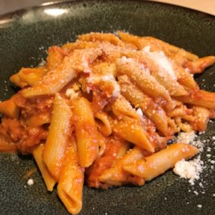
Chef John's Penne with Vodka Sauce
Prep Time 15 minutes Cook Time 50 minutes
6 Servings

Ingredients
8 pieces center cut bacon, diced
1 small sprig fresh rosemary
1 Tbs olive oil
½ cup vodka
½ cup heavy whipping cream
Freshly ground black pepper to taste
3 cups prepared marinara sauce
¾ cup water
14.5 oz penne pasta
½ cup freshly grated Parmesan cheese

Directions
- Cook and stir bacon and rosemary sprig with olive oil in a large, deep skillet over medium heat until bacon renders its fat but is not crisp, about 5 minutes.
- Pour vodka into the skillet, standing back to avoid any flare-ups. Raise heat to high and continue to cook until the vodka reduces to about 2 tablespoons.
- Pour heavy cream into skillet, stir briefly, and add black pepper. Bring sauce to a boil.
- Reduce heat to medium; cook and stir until sauce has slightly reduced, 3 to 4 minutes.
- Mix marinara sauce and water into cream mixture and bring to a simmer. Lower heat and simmer sauce 20 to 25 minutes to blend flavors.
- Fill a large pot with salted water and bring to a boil. Stir in penne and return to a boil. Cook pasta, stirring occasionally, until cooked through but still chewy, about 10 minutes; drain and return to pot. Pour sauce over penne and stir to combine. Turn off heat, cover pot with a lid, and let stand 5 minutes for pasta to absorb sauce. Serve sprinkled with Parmesan cheese.

